**Lesson 6 Demo 1**

**Understanding Service Topology**



Steps to be followed:

1. Routing through local endpoints only
2. Routing through local endpoints as a preference

**Step 1: Routing through local endpoints only**

* 1. Create a service to route only through the local endpoints using the below command:

***vi localendpointsvc.yaml***

* 1. Add the following code to the file:

***apiVersion: v1***

***kind: Service***

***metadata:***

***name: my-service***

***spec:***

***selector:***

***app: my-app***

***ports:***

***- protocol: TCP***

***port: 80***

***targetPort: 9376***

***topologyKeys:***

***- "kubernetes.io/hostname"***

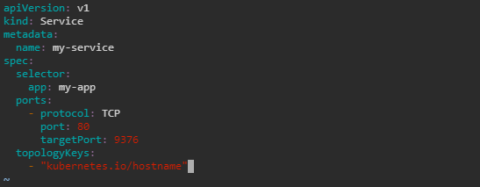

* 1. Create the resource using the below command:

***kubectl apply -f localendpointsvc.yaml -n test***



* 1. Describe the created service with the following command:

***kubectl describe service my-service -n test***

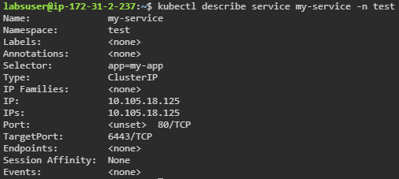

**Step 2: Routing through local endpoints as a preference**

1. Create a service configuration file

***vi localendpointsvc-localpref.yaml***

1. Add the following code to the file:

***apiVersion: v1***

***kind: Service***

***metadata:***

***name: my-service-local-pref***

***spec:***

***selector:***

***app: my-app***

***ports:***

***- protocol: TCP***

***port: 80***

***targetPort: 9376***

***topologyKeys:***

***- "kubernetes.io/hostname"***

***- "*"***

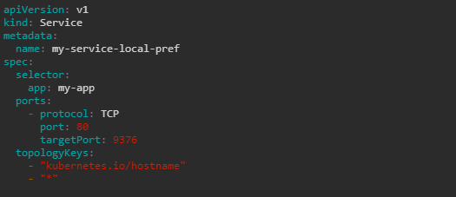

1. Create the resource using the below command:

***kubectl apply -f localendpointsvc-localpref.yaml -n test***



1. Check the service created using the following command:

***kubectl describe service my-service-local-pref -n test***

